**Patient Master**

* PURPOSE OF THE Patient Master.

“Patient Master” is used in “Prescription Master”.

1. Select “Patient Master” Menu Path :- Masters->Pharma Retails Masters--> Patient Master.

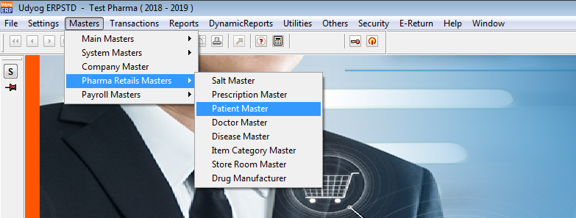

2.After Click On “Patient Master”

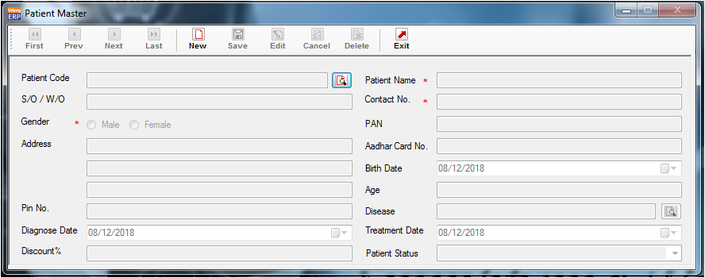

3. Validation list.

1. Invalid PAN Card Number not allowed.
2. Invalid Aadhar Card Number not allowed.
3. Duplicate Record not allowed.